**INTI International College Penang School of Engineering and Technology**

**3+0 Bachelor of Science (Hons) in Computer Science, in collaboration with Coventry University, UK**

**3+0 Bachelor of Science (Hons) in Computing, in collaboration with Coventry University, UK**

**Coursework cover sheet**

**Section A - To be completed by the student**

|  |  |
| --- | --- |
| Full Name: Matthew Loh Yet Marn | |
| CU Student ID Number: 13445539 | |
| Semester: 1 | |
| Session:  **August 2022** | |
| Lecturer:  **Nadhrah Abdul Hadi (nadhrah.abdulhadi@newinti.edu.my)** | |
| Module Code and Title:  **4067CEM Software Design** | |
| Assignment No. / Title:  **Continuous Assessment** | % of Module Mark:  **50** |
| Hand out Date:  **6th September 2022** | Due Date:  **Task 1: 30 September 2022, by 11.59pm.**  **Task 2: 18 November 2022, by 11.59pm**  **Task 3: 4 November 2022, by 11.59pm.**  **Task 4: 4 November 2022, by 11.59pm.**  **Task 5: 4 November 2022, by 11.59pm.** |
| Penalties: No late work will be accepted. If you are unable to submit coursework on time due to extenuating circumstances, you may be eligible for an extension. Please consult the lecturer. | |
| Declaration: I/we the undersigned confirm that I/we have read and agree to abide by the University regulations on plagiarism and cheating and Faculty coursework policies and procedures. I/we confirm that this piece of work is my/our own. I/we consent to appropriate storage of our work for plagiarism checking.  Signature(s): ________________________ | |

**Section B - To be completed by the module leader**

|  |  |  |
| --- | --- | --- |
| Intended learning outcomes assessed by this work:  1. Understand and apply appropriate concepts, tools and techniques to each stage of the software development  2. Understand and apply design patterns to software components in developing new software  3. Demonstrate an understanding of project planning and working to agreed deadlines, along with professional, interpersonal skills and effective communication required for software production  5. Demonstrate an awareness of, and ability to apply, social, professional, legal and ethical standards as documented in relevant laws and professional codes of conduct such as that of the Malaysian National Computer Confederation. | | |
| Marking scheme | Max | Mark |
| 1. User Story Mapping 2. Setting up a GitHub Repository 3. Creating a Class diagram and design pattern selection 4. Creating a Prototype User Interface and Usability Testing 5. Discuss the ethical issue related to the software | 20  10  30  20  20 |  |
| Total | 100 |  |

Task 4 - Creating a Prototype User Interface and Usability Testing (20 marks)

Matthew Loh Yet Marn – 13445539

**BACKGROUND**

In this task, we carry out the prototyping of the College Buddy System. Software testing crucially helps ensure that the product is above all, attractive whilst still being functional. Usability testing through a digital prototype can help to identify issues with the software on both a granular and big-picture scale. In designing software, the fundamental goal is to leave the user with an overall positive impression after using the software. To achieve this, the prototype must stick to design principles that are built on various other fundamentals like clarity, consistency, and simplicity. Testing is a meticulous and analytical task that allows the realistic contextualization of the software’s ins and outs from the audience. Through testing, resulting metrics must cover aspects like user satisfaction, task completion rates, time spent on tasks and error rates. Usability testing must be carried out after carrying out the prototyping of the system.

There are many more reasons for software testing, but a final key reason is to improve the usability of the software by understanding the context in which the audience intends to use it. By conducting usability testing through a digital prototype, the College Buddy System can be better understood in how users respond to the software’s user interface, navigation and discoverability as intended on a mobile platform.

**Prototypes of two main functions in the College Buddy System (CBS by INTI).**

In this task, two important functions of the tentative system will be prototyped, which are the Meetup Organization and Find-a-Buddy functions. The main attraction of the College Buddy System is its ability to harmoniously integrate software’s advantages with the human connection, which necessitates the selection of these two functions to be most optimal for testing. As an INTI Penang student, a big part of college life is the process of meeting people and making plans with each other to enjoy the company of one another. Aligning with this intention, the prototypes presented below intend to provide an attractive way to further smoothen the convenience of the process. The prototypes were created and configured in Figma.

**RESULTS**

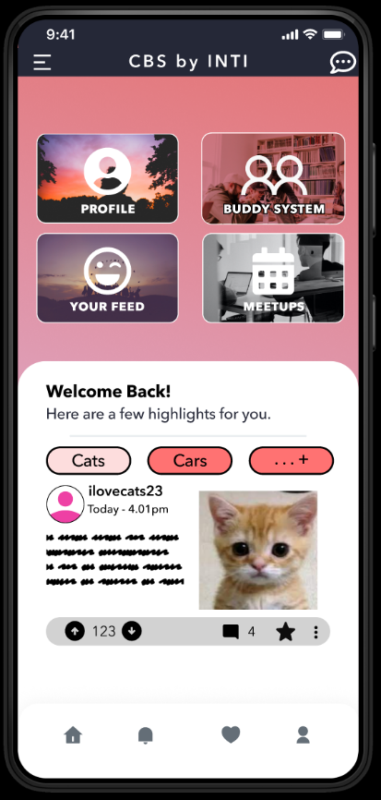

**Figure 1.1: Main Page of the CBS by INTI used to navigate to the meetup menu and buddy system.**

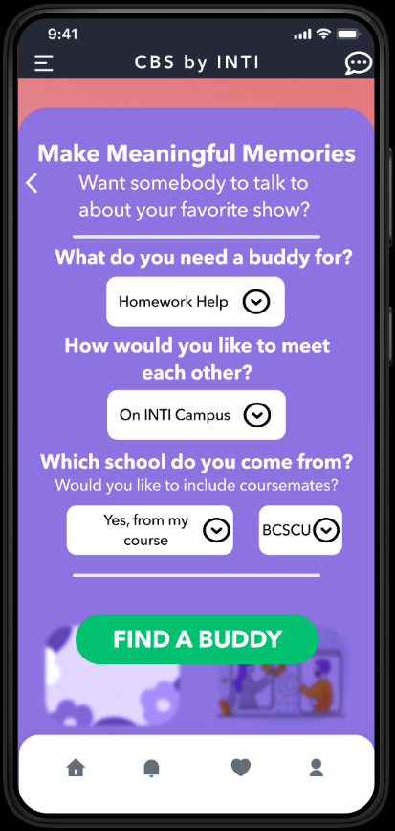

**Figure 1.2: Landing Page of the Buddy System**

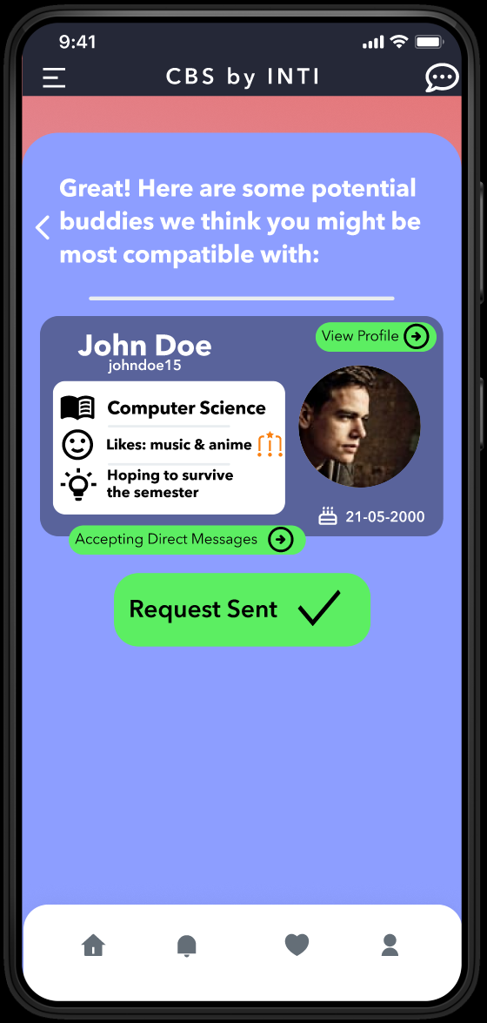

**Figure 1.3: Presentation View of the Buddy Select Page**

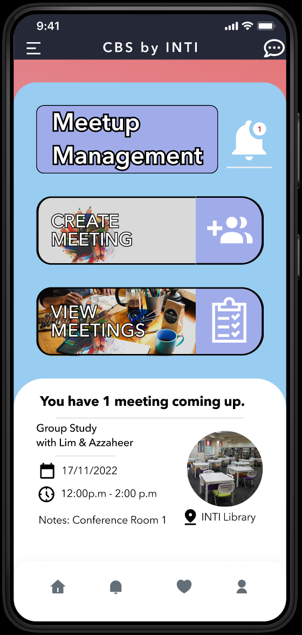

**Figure 1.4: Main Page View of the Meetup Organization Page**

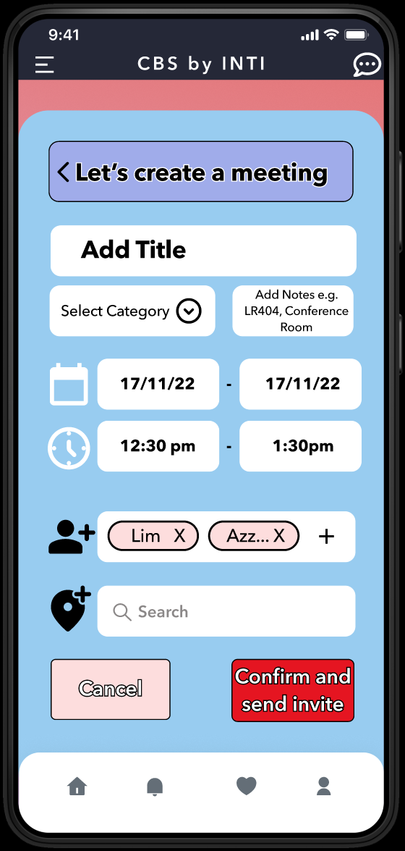

**Figure 1.5: View of the Meetup Creation Page**

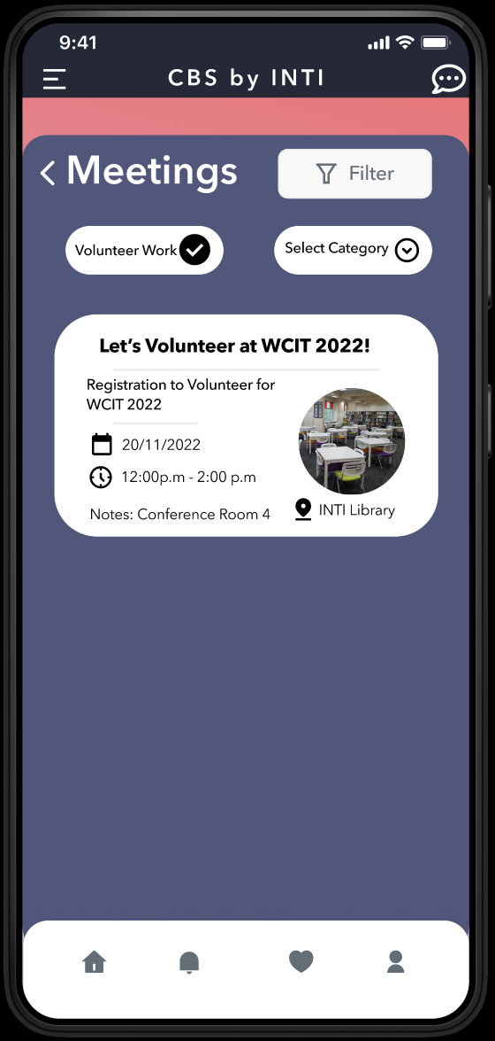

**Figure 1.6: View of the Meeting Tracker/View Page**

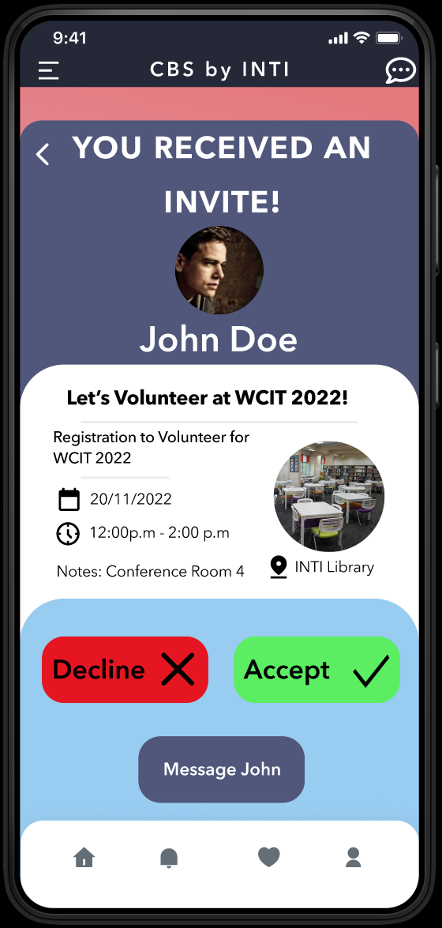

**Figure 1.7: View of the Meeting Invite Notification Page**

**Usability testing approach**

In the usability testing of these two functions, a proper strategy must be implemented to draw up the tasks that the user should effectively test for. Observations need to be made in certain key aspects including the user’s experience in navigating through the various pages. A holistic approach needs to be taken in capitalizing on the optimization opportunities created through observing the user. To achieve this, the usability testing questions for this phase should be constructed to test for realistic and often overlooked details. In this case, the questions are made in mind of metrics including the previously mentioned task completion rate, error rate, time spent on task and satisfaction rating. The usability testing questions also have to factor in the audience’s experience with technology testing in general and as such, design terms should be converted as systematically and simply as possible to be implicitly derived.

**USABILITY TESTING QUESTIONS**

**Part 1: Find-a-Buddy System**

1. From the main page, could you kindly navigate to the Find-a-Buddy page?
2. In the Find-a-Buddy page, how easy was it to operate the interface to select criteria to filter buddies by?
3. What kind of additional filtering options would you like to see on the Find-a-Buddy page?
4. Kindly input the following filters, to find a buddy, select Homework Help. For the preferred way of meeting the buddy, select on campus.
5. You intend to meet up with coursemates, in the interface, how intuitive is the text guidance provided?
6. Please describe your first impressions of the filtering screen, does the FIND A BUDDY button immediately attract your attention?
7. After tapping on the button, please return to the main page to change your filtering options.
8. How easy is it to extract profile information at a glance of potential buddies in the matchup screen?
9. What other kind of criteria would you like to be matched by?
10. How easy was the system to use in viewing the buddy’s profile and sending a buddy request together with sending a message to the buddy?

**Part 2: Meetup Organization System**

1. From the main page, please navigate to the Meetup Organization page.
2. What immediately jumps out to you in terms of interactable elements of the Meetup Management Page?
3. Please create a meeting with the title Tea Time Post Class, how easy is it to designate a category and was it possible for you to fill in the correct information you needed?
4. Please select the location of the meeting to be in the INTI Café using the search field. Does the picture of the location help you to decide on alternative locations?
5. Please invite one or more friends using the invite field. Were you able to find your buddies easily?
6. Were you able to rectify typos and errors at the designated time and date?
7. Navigate to the View Meetings page, does the meeting you created show up with the correct details?
8. Are there any features missing that you would expect to make tracking and organizing meetings easier?
9. Navigate back to the Meetup Page, and click on the notification icon, were you able to notice the notification easily?
10. On the RSVP screen, please accept the invitation but message John that you would like to reschedule the meetup.

**CONCLUSION & LINK TO FULL PROTOTYPE**

To conclude, the prototype was designed to appeal to younger audiences who maintain high standards towards aesthetically pleasing software. Modern design choices such as icon buttons were used. The prototype also includes various quality-of-life navigation buttons including a side nav bar which is accessible on the left of the header and a bottom navigation bar with intuitive icons. The elements were laid out to provide the best viewing experience on the relatively small real estate provided by modern smartphone standards. Possible improvements include the prototype implementation of the feed system, which due to difficulty in creation, was left out. Here, more allure is given to the user to participate and contribute to the discussions of various day-to-day topics. The prototype is a proof-of-concept of the ideas behind the College Buddy System according to the User Story Mapping created in Task 1. In viewing the prototype, click on the screen to view the interactable elements. The prototype includes the sign-in page, sign-up page, profile page, buddy system, meetup page, hidden side navigation menu and various others that conform to modern standards.



Please click on the play button to enter the prototype view.

Link to editor view:

<https://www.figma.com/file/S7WdOfaAmQSfQOjZGYMrdd/Software-Design---College-Buddy-System-Prototype?node-id=0%3A1&t=yjKHmoRZ8CkYuiGx-1>

Link to prototype:

<https://www.figma.com/proto/S7WdOfaAmQSfQOjZGYMrdd/Software-Design---College-Buddy-System-Prototype?node-id=1%3A2&scaling=scale-down&page-id=0%3A1&starting-point-node-id=1%3A2>

For more information, please WhatsApp me at 019-388-4019 😊